Colour Codes and Number Codes of Components for Unit Identification :
Electronic and electrical components are often marked with colour bands or numbers to indicate their values, ratings, and tolerances. These coding systems make it easy to identify components quickly without measuring them.

1. Colour Code System
A. Resistors
A resistor is a passive electronic component used to oppose the flow of electric current in a circuit. It helps in controlling current and producing voltage drop.
Unit of resistance: Ohm (Ω)
1. Functions of a Resistor
- Limits Current
  - Protects components like LED, IC, and transistor from excess current.
- Drops Voltage
  - Used to reduce voltage in circuits.
- Voltage Divider
  - Used to get a required output voltage from a higher input voltage.
- Biasing
  - Used in transistor circuits to set proper operating point.
- Pull-up / Pull-down
  - Used in digital circuits to keep input pins stable (HIGH or LOW).
- Power Dissipation
  - Converts electrical energy into heat to protect the circuit.
2. Ohm’s Law
Where:
- V = Voltage (Volt)
- I = Current (Ampere)
- R = Resistance (Ohm)

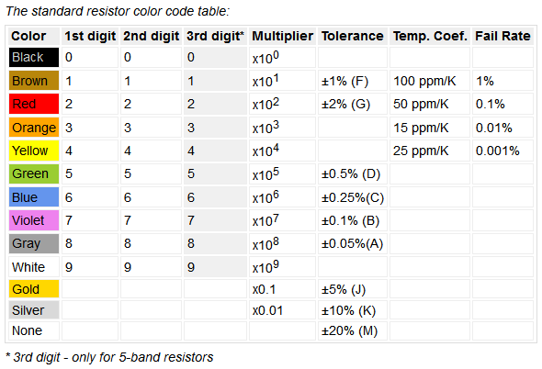
Resistors use colour bands to indicate resistance value and tolerance.
- Standard 4-band resistor code:
  - First band: 1st digit
  - Second band: 2nd digit
  - Third band: Multiplier (power of 10)
  - Fourth band: Tolerance

47 kilo
2.2kilo ohm
22 x100 +-5 %
4th resitor 1.5kilo ohm +-5
47 ohm +-5
39kilo ohm +-5 %
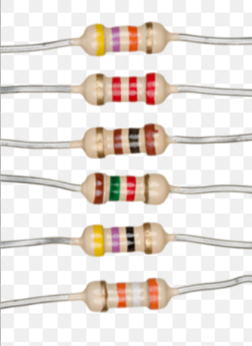
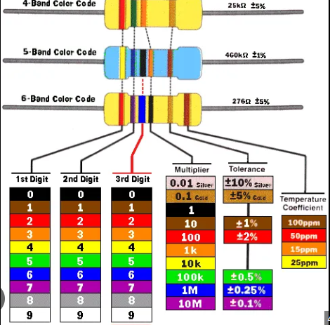

B. Capacitors
- Some small capacitors use colour codes similar to resistors.
- Electrolytic capacitors usually use numerical codes (e.g., 104 = 100,000 pF = 0.1 µF) = 100nf
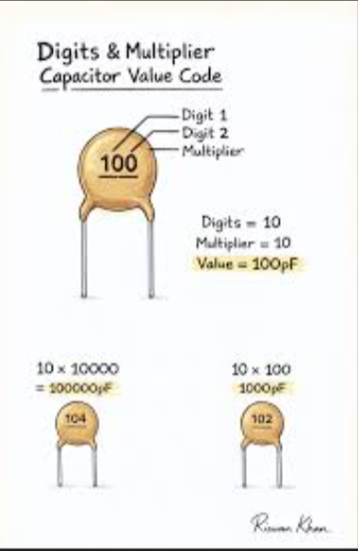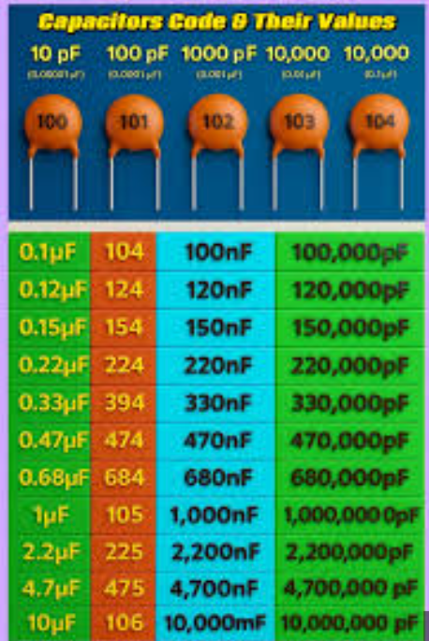
C. Inductors
An inductor is a passive electronic component that stores energy in the form of a magnetic field when current flows through it.
Unit of inductance: Henry (H)

- Inductors may also use colour bands similar to resistors to indicate inductance and tolerance.
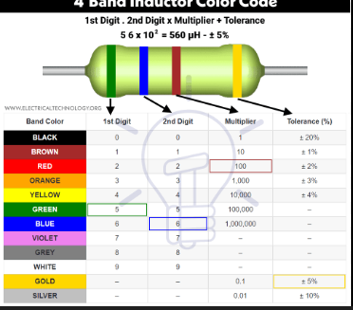
1. Working Principle of Inductor
An inductor works on the principle of electromagnetic induction.
When current passes through a coil:
- a magnetic field is created around it
- if current changes, the inductor opposes that change
This opposition is called inductive reactance.
Transistor :
Transistors are electronic devices used for amplification and switching. They come in bipolar junction transistor (BJT) and field-effect transistor (FET) types. Identification is important for choosing the correct component in a circuit.
1. Number Code System
Transistors are usually marked with alphanumeric codes:
A. Bipolar Junction Transistors (BJT)
- Format: Letter + Numbers
Example: BC547, 2N2222, BD139
- Explanation:
  - BC547 (Europe standard)
    - B = Low power transistor
    - C = Silicon material
    - 547 = Serial number
  - 2N2222 (JEDEC standard)
    - 2N = 2 junctions (BJT)
    - 2222 = Serial number
- Some transistors have suffix letters to indicate hFE (gain) grouping:
  - e.g., BC547A, BC547B, BC547C
    - A = low gain
    - B = medium gain
    - C = high gain
B. Field Effect Transistors (FET)
- Usually marked with alphanumeric codes like: IRF540, BF256
  - Manufacturer datasheet is used to decode specifics.
- Some may have colour dots or bands to indicate polarity or type (N-channel/P-channel).
2. Colour Code System for Small Signal Transistors
- Through-hole small signal transistors rarely use colour bands, but in some high-reliability applications they do:
Colour | Collector | Base | Emitter | Notes
Red | + |  |  | May indicate PNP type
Black |  |  |  | Common for NPN type
Green |  |  |  | Sometimes used for gain grouping
Colour codes for transistors are less standardized than resistors; the number/code printed is usually sufficient.
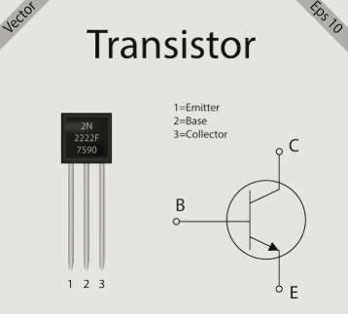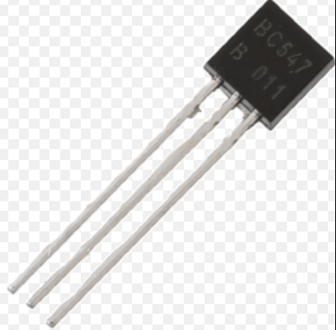

Voltage Regulated Components / Units
Voltage regulation ensures that a device or circuit receives a constant voltage regardless of changes in load or input supply. Voltage regulators are widely used in power supplies, electronic devices, and embedded circuits.
1. Types of Voltage Regulation
A. Linear Voltage Regulators
- Maintain a steady output voltage by dissipating excess voltage as heat.
- Common ICs:
  - 78xx series – Positive voltage regulators (e.g., 7805 = +5V)
  - 79xx series – Negative voltage regulators (e.g., 7905 = -5V)
- Features:
  - Simple to use
  - Low noise
  - Inefficient for large voltage differences due to heat loss
B. Switching Voltage Regulators
- Convert input voltage to output voltage using high-frequency switching.
- Types:
  - Step-down (Buck)
  - Step-up (Boost)
  - Inverting
- Advantages:
  - High efficiency (~80–95%)
  - Can increase or decrease voltage
- Disadvantages:
  - More complex
  - Generates high-frequency noise
2. Voltage Regulator IC Identification
Voltage regulator ICs have number codes for identification:
IC Code | Output Voltage | Type | Notes
7805 | +5 V | Linear | Most common positive regulator
7812 | +12 V | Linear | Positive voltage
7905 | -5 V | Linear | Negative voltage
LM317 | Adjustable | Linear | Output set by resistors
LM78xx/LM79xx | Various | Linear | Standard positive/negative
LM2575 | Adjustable | Switching | Step-down
- Pinout (TO-220 package for 78xx):
  - Input voltage
  - Ground
  - Output voltage

3. Colour Coding / Number Coding
Voltage regulators rarely use colour codes. Instead, they are identified by:
- Printed number code on the IC body (e.g., 7805, LM317)
- Suffix letters may indicate tolerance or packaging:
  - LM317T → TO-220 package
  - LM317K → TO-3 package
Example:
- A 7805 IC → Provides regulated +5V output
- LM317 → Adjustable; output = 1.25V × (1 + R2/R1)
4. Applications
- Power supply circuits
- Microcontroller circuits (Arduino, Raspberry Pi)
- LED drivers
- Battery chargers

